Maths semaine du 8 juin au 12 juin.
To look at the previous math video lessons, go under the video tab.
Périmètre et Aire : You have a week to complete this work.
Lundi : Regarde cette vidéo sur le périmètre et celle sur l’aire
Download the document Périmètre et Aire
On this document, you will find 5 lessons that explain step by step the:
- Perimeter
- Covert measures (students should already know)
- Missing value: when we are missing information, so you must deduct.
- Area
- Area of triangles and trapezoids

For each lesson, you will find a worksheet that you must do. Answer sheets are provided as well.
You will also find 24 cards with a problem on it. You can resolve all problems on the answer sheet or on a piece of paper. Answers are provided as well.
Finally, you will find some writing and creative problems with all the instructions and the sheets to complete them.
For more advanced work:
Video about Volume
Questions for Area of triangles
Trouve le périmètre et l’aire de cette forme? Suppose que les mesures sont en mètre.
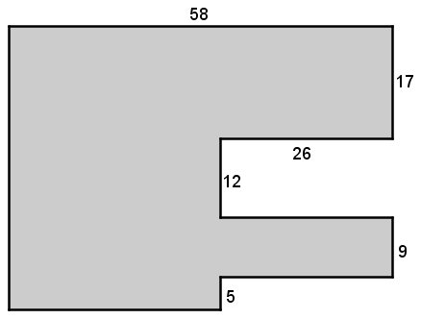
Périmètre =

Aire =

Have a good week!

